Instructions and Sample for ZIP File Copy: In A4 Size Page
(Page Count: 5)
X.X. Xxx ¹
Y.Y. Yyy ^{2,}*
Z.Z. Zzz ^{1,3}
_____________________
*Corresponding author
¹ ^^^^^^^^ University, City, Country, title, zzz@zzzz.zzz
² ^^^^^^^^ University, City, Country, title, zzz@zzzz.zzz
³ ^^^^^^^^ University, City, Country, title, zzz@zzzz.zzz

ABSTRACT
Please read every section in this document carefully to help us maintain the quality of its publication. Any paper with unacceptable quality will not be included in the post-conference proceedings book. Note that your paper for the initial submission must be anonymized for the double-blind reviews. Once the paer is reviewed and acceptd for presentation, you will need to de-anonymized and restore the author information back to the first page. All papers will be zipped into one single ZIP file and shared during the conference. Please format your paper like this page in a single-column format. Every paper must identify with “*” only one corresponding author on the author list and put a footnote of “*Corresponding author” as shown above. The page format should be standard A4 size, and all texts are in 10pt and Times New Roman font, except Title (14pt) and Author List (12pt). The paragraph must be single-spaced. Save and upload your paper in PDF format to replace the old PDF file in the EasyChair system (not in MS-Word’s DOC format as we will not paginate your content for the ZIP file). This page format will be used later for the post-conference proceedings book. Finally, the editorial office reserves the right to exclude any paper for which the authors are not fully taking responsibility and might delay the publication date of the ZIP file. The author will be notified of this action.

Please note that the easiest way to comply with the page format is to copy and paste your paper content from the source to this template.

Keywords: Format instruction, ICEB, e-business, electronic commerce, headers, and footers.

Introduction
Margin
The top and bottom margins for the text should be 2 centimeters (57 pt.). Those for left and right are 1.5 centimeters (43 pt.).

Header and Footer
Each page should include a header and a footer. Top margin for the header, and the bottom margin for the footer should be one centimeter. Both the header and the footer should be single-spaced. The header is right-justified containing the last name(s) of the author(s). On the title page only, insert a table with two columns having the citation information of the paper on the left and the author name list on the right. Please make the frame line invisible. The conference name on the left and the authors’ last names on the right should be italic.

You need to configure the header of title page be different than the remaining pages. The footer should be centered with the italic conference name, e.g., ‘The 18th International Conference on Electronic Business, Guilin, China, December 2-6, 2018’. Enter the header area and click the “Design” tab on the menu. Set the distances of both “Header from Top” and “Footer from Bottom” to 0.71 centimeter. Also, check the box of “Difference First Page”. Please use the format on this page as an example and hide the table frame when you complete the header content. Figure 1 shows the settings in the “Page Setup” dialog box.

FORMAT INSTRUCTIONS
Title
The title of your paper should be in bold face, initial cap of every word, single-spaced, and centered across the top of the first page. Below the title, please indicate the page count in parentheses. This indication will be removed from the content when the proceedings book is published. Note that the title in the header should be all in lower case with an initial cap of the first word.

Authors
The name of author, affiliation, country, and e-mail address should be centered with initial caps. Do not use titles such as Dr., Professor, etc.

Headings
First-level headings
All headings should be in bold face. First-level headings should be centered and set in caps.

Subheadings
Second-level subheadings should be set flush left with initial caps of all words. Third-level subheadings should be set flush left with initial cap and italic font. Please do not use headings other than these three types. A one-line space should separate these sub-/headings from the preceding text.’

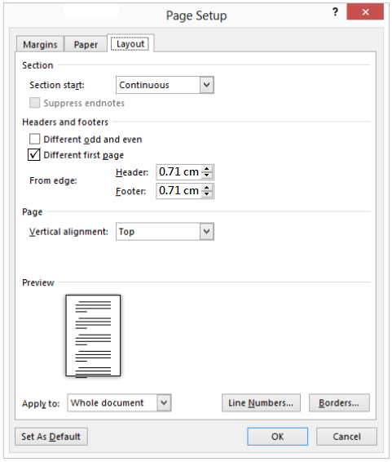
Source: Microsoft (2021).
Figure 1: Header and footer positions set-up parameters.

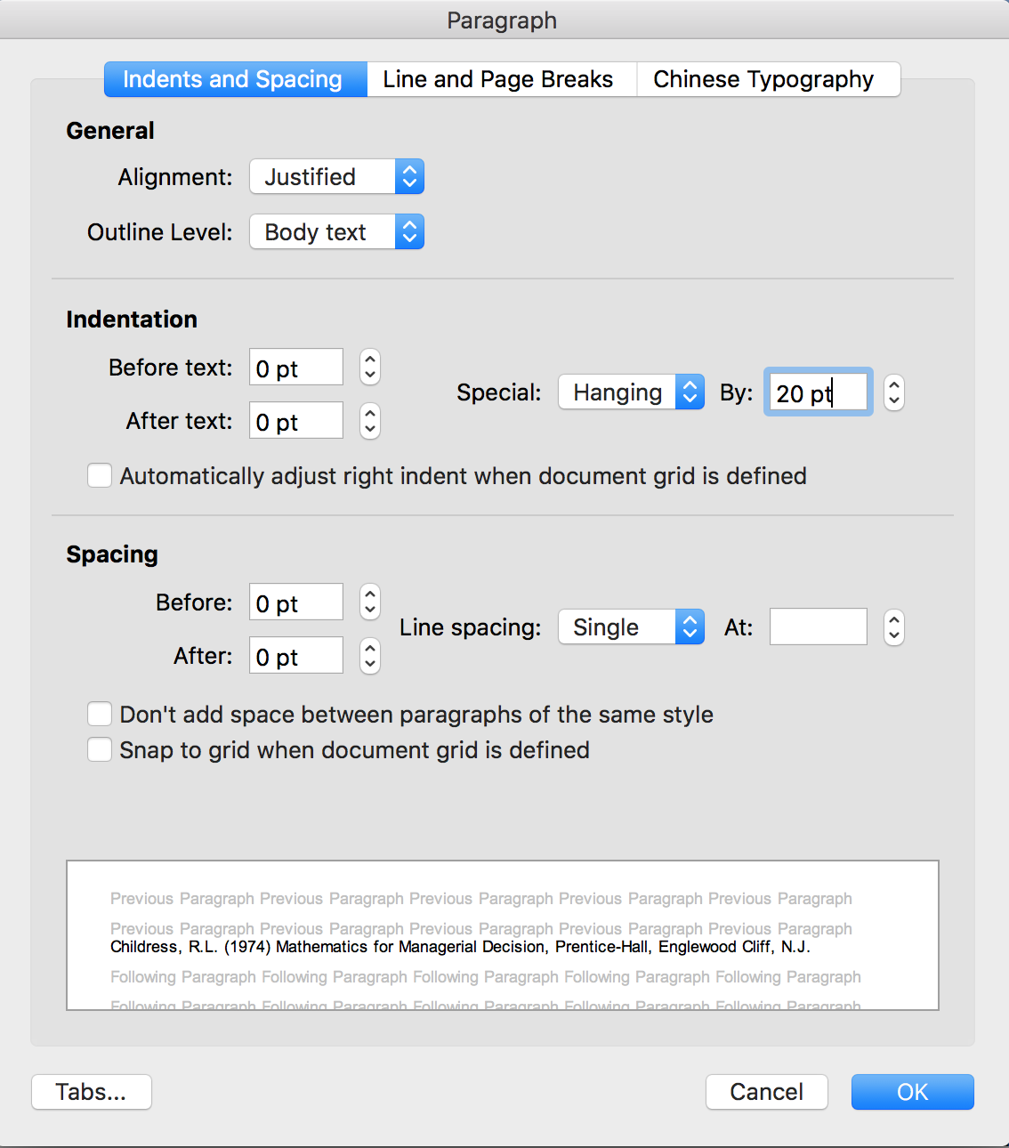
Source: This study.
Figure 2: Paragraph set-up parameters for the reference list.

Abstract
Introduce the paper with an abstract of approximately 100 words. Begin with centered heading “ABSTRACT” set above the single-spaced abstract text. The abstract should properly describe the findings or arguments presented in the paper.

Keywords
Keywords should be set flush left one line below Abstract with no more than 20 words.

Body
Below the abstract, you begin with a first-level heading that introduces the body of the paper. All paragraphs should begin flush left (no paragraph indent) and right justified. Single-space the body of the paper. A one-line space should be placed between two paragraphs. Please carefully read the guidelines of Publication Ethic at http://iceb.johogo.com/PubEthics.htm and follow them closely for content preparation.

Figures and Tables
Figures and tables should be centered on the page and placed as close as possible to where they are cited. They must be numbered in sequence respectively. The caption of a table or figure states the sequence number and its title, separated by a colon, e.g., “Figure 1: Research Model” and “Table 1: Summary Statistics”. A figure caption should be placed and centered below the figure while a table caption above the table. A multiple-line title must be indented and aligned with the first character of the title.

Calling References
- All citations must be in APA (American Psychological Association) format styles with complete and accurate information. If any citation is not correct and complete (e.g., missing volume, issue, or page number, publisher name or city, etc.), it reflects that you did not retrieve the paper; not to mention reading it. It also implies that your paper is not highly accurate and therefore will not be included in the final proceedings book to be indexed by EI Compendex and Scopus.
- The scholar.google.com website is an easy way to retrieve citations as it uses APA styles. However, the information it generates might not be complete. If it is not complete, you must visit successfully the cited paper online or offline yourself to create the complete and correct information. If you do not have the time to do it yourself, you should find a professional editing service to do it for you.
- Normally you should include only up to 30 references in the paper. Thus, please include only those papers you have read and found related to your research significantly. Please do not include insignificant papers.
- References in the paper must be from books, book chapters, journals, conferences, corporate reports, survey reports, working papers, or other digital archives that can be retrieved from scholar.google.com or other online websites.
- Informal publications such as blog, personal communications, news, etc. should be avoided.
- All titles of references must be searchable over the Internet. The editorial office retains the right to remove references that are not searchable on the Internet.
- Please make sure that every citation in the context is listed in the References section. Any reference not cited in the context should be removed.
- The editorial office is only responsible for checking your compliance with consistency and correctness of the references. We will correct minor format errors for you but not to make the information complete and accurate.
- Please see Table 1 for the reference styles in the paper body. Figure 3 demonstrates the APA citation can be retrieved from scholar.google.com output.

Table 1: The reference styles in the text.
No. | Style Rule
 | Where there is more than one reference from the same author(s) in the same year, references should be identified by suffix letters, e.g., Zhang and Cao (1995a, 1995b), Yen et al. (2015).
 | Inside parentheses, the citations look like “(Zhang & Cao, 1995a, 1995b; Yen et al., 2015)”.
 | References should be made only to works that are published, accepted for publication (not merely 'submitted'), or available through libraries or institutions.
 | Any other source should be qualified by a note regarding availability, e.g., website address and retrieval date.
Source: This study.

Footnotes Free
The use of footnotes is not allowed.

Searchable References
Please make sure all references are searchable on and confirm to the APA styles of Google Scholar Website.

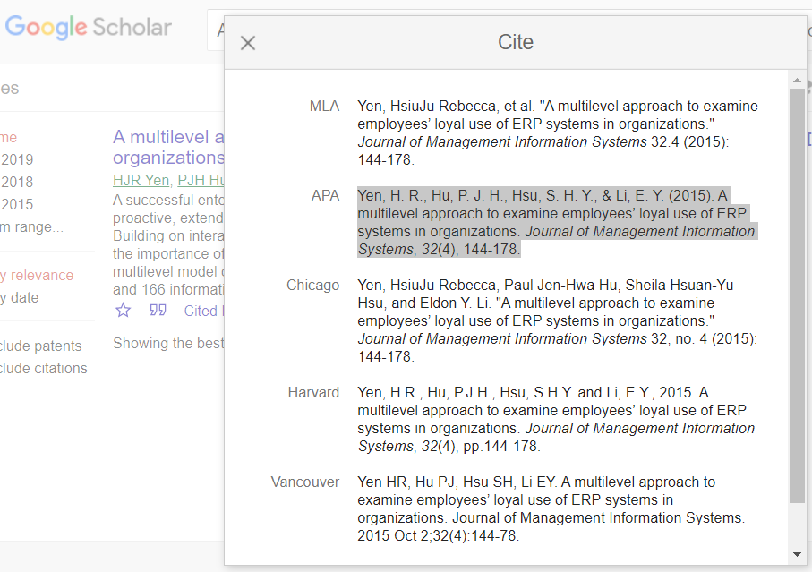
Source: The source reference should be placed on the bottom left corner of the table/figure and within the width of the table/figure. It could be longer than the title of the table/figure but requires indentation and a line space before the title.

Figure 3: The APA citation from scholar.google.com.

Equations
All equations should be centered on separate lines and numbered consecutively, with the equation numbers placed within parentheses and aligned against the right margin.

Ri = f(Xi) (1)

ACKNOWLEDGMENT
This work is partially supported by the Humanities and Social Sciences of Ministry of Education Planning Fund (17YJA630050) in China and the Ministry of Science and Technology (Grant No. 108-2410-H-033-042-MY3) in Taiwan.

REFERENCES
Childress, R.L. (1974). Mathematics for Managerial Decision. Englewood Cliff, N.J.: Prentice-Hall.
Du, T.C., Li, E.Y., & Chang, J. (2002). Implementing association rule techniques in data allocation scheme of distributed databases. Working paper, Faculty of Business Administration, The Chinese University of Hong Kong, Shatin, N.T., Hong Kong, January.
Granovetter, M. (1992). Problems of explanation in economic sociology. In N. Nohria and R. Eccles (Eds.), Networks and Organizations: Structure, Form and Action (pp. 25–56). Boston, MA: Harvard Business School Press.
Kogut, B. (1991). Designing global strategies: Comparative and competitive value-added chains. In H.V. Wortzel & L.H. Wortzel (Eds.), Strategic Management of Multinational Enterprise: The Essentials (pp. 100-115). New York: John Wiley & Sons.
Merriam-Webster (1993). Merriam-Webster's Collegiate Dictionary (10th ed.), Springfield, MA: Merriam-Webster.
O'ullivan, O. (2000). Net banks: More dream than reality. U.S. Banker. Retrieved from http://www.us-banker.com (accessed 18 February 2011).
Pearson, S.W. (1977). Measurement of computer user satisfaction (Doctoral dissertation, Arizona State University, Tempe, AZ).
Pitts, J.E. & Whitaker, W.M., III. (1971). The impact of tax policy on investment behavior in the chemical industry, 1951-65. Decision Sciences, 2(1), 53-65. https://doi.org/10.1111/j.1540-5915.1971.tb01593.x
Yen, H.J., Hu, P.J.H., Hsu, S.H.Y., & Li, E.Y. (2015). A multilevel approach to examine employees' loyal use of ERP systems in organizations. Journal of Management Information Systems, 32(4), 144-178. https://doi.org/10.1080/07421222.2015.1138373
Yin, C. J., Ren, L. Z., & He, R. K. (2008). Discussion on the creative product design method based on concurrent mode. Packaging Engineering, 29(06), 117-118,199. https://doi.org/10.3969/j.issn.1001-3563.2008.06.065 (in Chinese).
Zhang, Q. & Cao, M. (2001). Human-machine Web interface design for electronic commerce: A review of design perspectives, objectives, dimensions, and techniques. In Proceedings of the First International Conference on Electronic Business (pp. 404-405). ICEB’01, Hong Kong, China, December 19-21.
Zinberg, J. (2016). Are provider-led health care networks too big to fail?. Health Affairs. Retrieved from http://healthaffairs.org/blog/2016/01/12/are-provider-led-health-care-networks-too-big-to-fail/ (accessed 20 September 2017).

Note for References Section
References should be listed at the end of the paper with complete information. The list of references should only include works cited in the text and have been published or accepted for publication. Please make sure all references are cited and all citations in the body have been listed in the reference list. Please include both the volume number and the issue number. Paper title with a subtitle, the first letter after the “:” must be capitalized. The journal names and book titles should be italicized. If available, please always include full DOI links in your reference list (e.g. “https://doi.org/id_number”).

The following references are listed only for examples; they are not all cited in the texts above. The format styles should follow the APA styles listed in http://www.icebnet.org/styles/ and the entries must be sorted in alphabetical order by the last names of the first author with the second line indented by 1 centimeter (see example below and the paragraph set up as shown in Figure 2). Please do not use a numerical system to identify and cite the references; otherwise, your paper will be desk-rejected immediately. Finally, a work-in-progress paper without conclusive analysis and results cannot be treated as a full paper even though it contains more than 8 pages.

WARNING: To encourage global knowledge exchange, you can cite foreign journals that are accessible through Internet. Nevertheless, the content must have English title and abstract, and a hyperlink (http://) to retrieve the cited paper online. Otherwise, the cited reference will be deleted by the editorial office during the final editing process. Also, any reference with an invalid hyperlink or cannot be searched over the Internet will be deleted. It is the author’s duty to ensure the quality of the references. Finally, non-English journal citations are limited to no more than 6 out of 30 (20%) only. Papers with more than 20% non-English journal citations will be desk-rejected automatically. For an example of a Chinese journal citation, please see the 10th citation (Yin, Ren, & He, 2008) in the REFERENCES section above.

APPENDIX A: Guidelines
The appendix should immediately follow the REFERENCES. If there is more than one APPENDIX, number each consecutively with APPENDIX A, APPENDIX B, and so forth.

APPENDIX B: Publication Ethics
The author must abide by the rule that the paper's content complies with the publication ethics stipulated at http://iceb.johogo.com/PubEthics.htm.

APPENDIX C: Content Quality
As the EI Compendex and Scopus indexes will not include abstract, the Proceedings book only publishes Full and Work-in-Progress papers. Please note that only those papers that have complete research (i.e., a full content with supportive concluding evidence) and a minimum of 8 pages will be published in the Full Paper category. Please understand that this condition is required to maintain our proceedings in the EI Compendex and Scopus indexes. When you upload the paper each time, please update the page count accurately behind the paper title to speed up the publication process. The editorial office reserves the right to evaluate the content and change the category of your paper or reject the paper when necessary.

Finally, please note that if you plan to submit your paper to a journal for publication, you should submit only the WIP Paper in only 4 pages because of the copyright issue. Thank you very much for your patience and cooperation in the ZIP file production process.

